**Phases of Ethical Hacking and Pentest Methodology with Parrot Security OS**

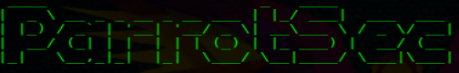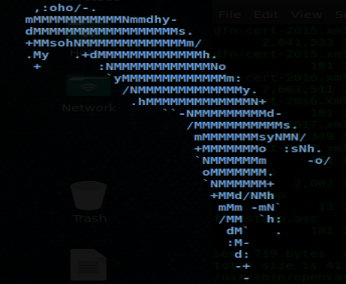

First of all, we must understand what is meant by a penetration test or a pentest:

**What is a Penetration Test?**

They are offensive evidence against the existing defense computing mechanisms in the business environment that is being analyzed in a given time and space. These tests can range from the analysis of physical and digital security devices to the analysis of the human factor using social engineering (the art of hacking human beings), it is well understood that the weakest link in the chain is the user.

**What is the objective of this project?**

The objective of the tests is to validate under extreme situations how defense mechanisms behave, specifically, to detect vulnerabilities in them. It also identifies lack of controls and gaps that may exist between sensitive information, users and existing controls.

**Why is it so necessary to perform a Pentest?**

There are many cases where organizations suffer incidents that could have been avoided if protection mechanisms had been strengthened at the time. Incidents include events such as information leaks, unauthorized access to systems, data loss, etc.

**What does a Pentest comprise?**

A Pentest comprises multiple stages with different types of activities in different settings and environments. The depth of the activities will depend on a number of factors, including the risk to the client of any of the methods applied during the assessment.

A prior agreement is established with the client to carry out the different phases of the analysis, which are described below:

**PHASE 1: RECOGNITION**

About this phase of a pentest we will focus on getting as much information as possible about the company or target available through scanners websites to give us an idea of the system and infrastructure, as well as the activity of employees in social networks of the company can also reveal the systems they use, their emails, etc... All this information will be of great use to us, the greater the amount of information obtained from the objective, the greater the opportunities in the exploitation phase.

**Important information to collect:**

* Locations: Shared/Individual as part of physical location identification it is important to consider whether the location is an individual building or a shared suite.
* Owner: Once physical locations are identified, it is useful to identify the actual owner(s). This can be an individual, group or corporation.
* Data Center Locations: The identification and location of the target business data center through some corporate website.
* Product/Services: Identification of the target business products and any meaningful data related to such releases through the corporate website, new versions or through a search engine can provide valuable information about the internal performance of an objective.
* Job Offers: Searching for current jobs or publications via the corporate website or through a job search engine can provide valuable information on the internal performance of a target.

**The recognition phase is divided into two types, passive and active:**

**Passive examples:**

* Dumpster diving.
* Searching for information in search engines such as Google (Google Dorks).
* Search the Internet database (Whois).
* Search for country and city where the servers reside.
* Search for domain names.
* Search contact information.
* Search for all the information that can be extracted from the DNS (Domain Name Server).
* Metadata.

**Active examples:**

* Social Engineering.
* Port Scanning.
* Use software tools to scan the network.
* Discover the range of IP addresses.
* Identify Operating Systems.
* Identify Device Names.
* Identify User Accounts.
* Search where the Routers are located.

**Some tools for Active use:**

**< When the active documentation is finished, a list of tools is made >**

**TheHarvester**

It is a tool, written by Christian Martorella, that can be used to collect email accounts and subdomain names from different public sources (search engines, pgp key servers). It is a really simple tool, but very effective.

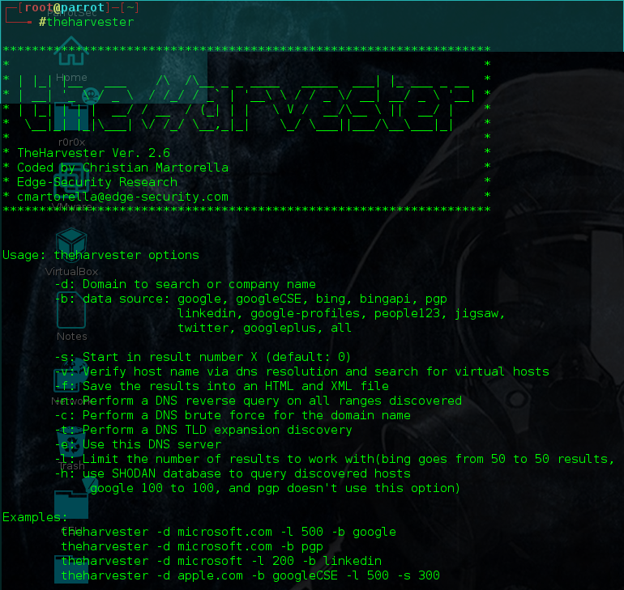

**The Harvester will search for the specified data source and return the results. This should be added to the document for use at a later stage.**

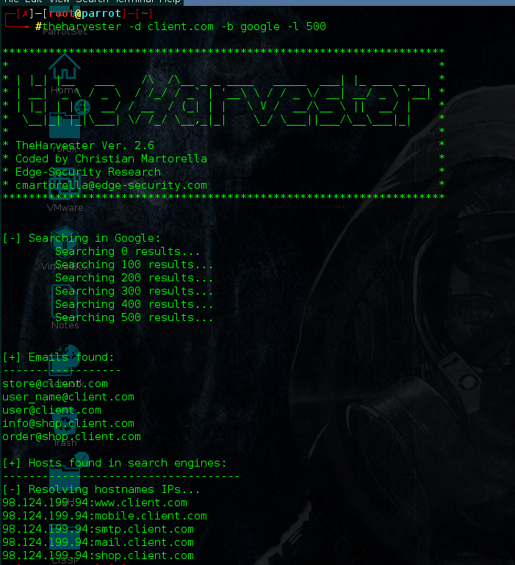

**Maltego:**

Paterva Maltego is used to automate the task of gathering information. Maltego is an open source and forensic intelligence application. Essentially, it is also a data mining and information gathering tool that maps the information collected in a format that is easy to understand and manipulate. Saves time by automating tasks such as email collection and subdomain mapping. Maltego's documentation is relatively scarce, so we are including the necessary procedures to obtain the required data.

Once you have started Maltego, the main interface must be visible. The six main areas of the interface are the toolbar, palette, graphics area (view), the

overview area, detail area and property area.

To start matego, we open the console and write "maltegoce".

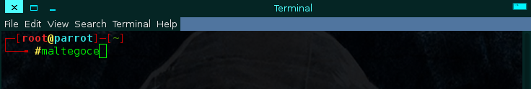

The following welcome screen will open, we press next, enter the email, the password and enter the captcha, if you do not have an account enter the option "register here", we give next.

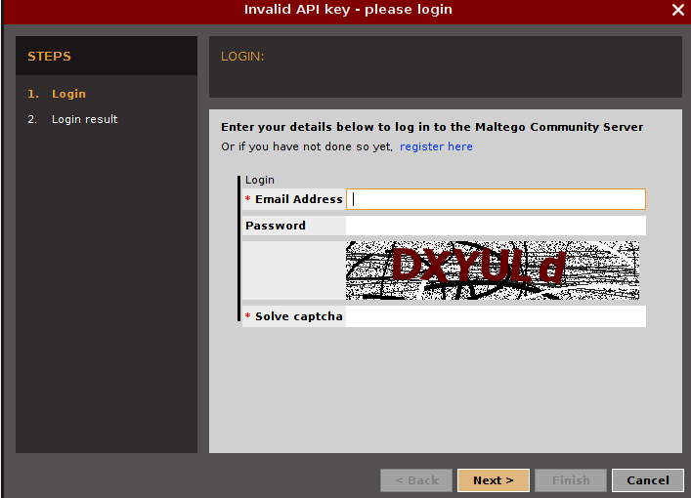

Once the credentials have been entered, the tool will be fully displayed.

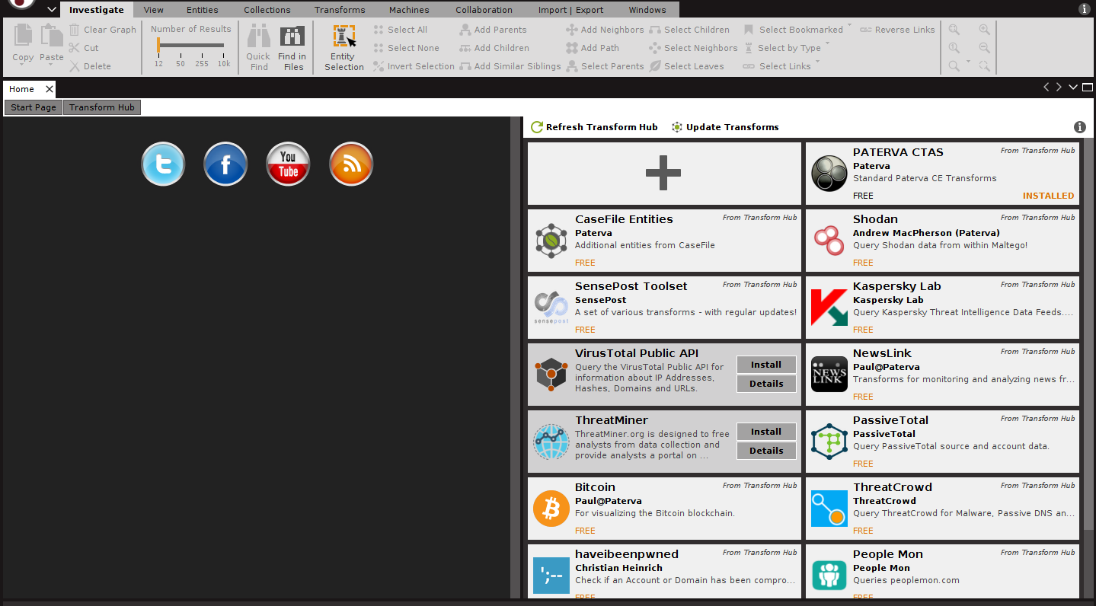

In the part of the menu in the upper left corner we click and choose in new project, the following image is shown on screen, where we will choose the type of scanning we want to perform.

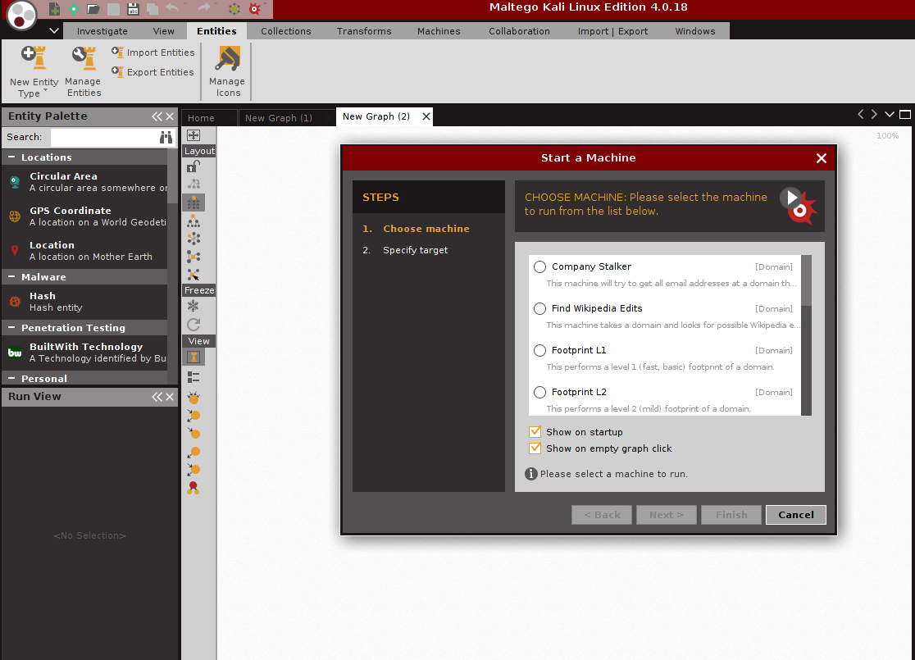

In this case we will choose Fingerprint L1, and next, the following screen is shown.

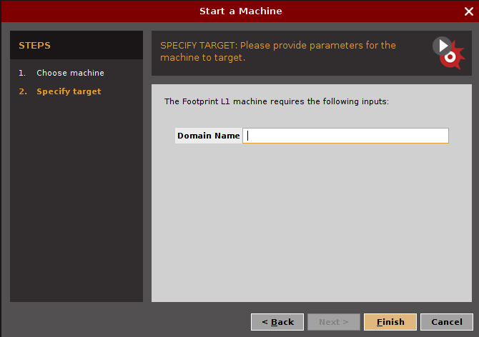

In the Domain Name option, type in the domain; for example:"client.com", the following screen is shown with the results found on the Internet.

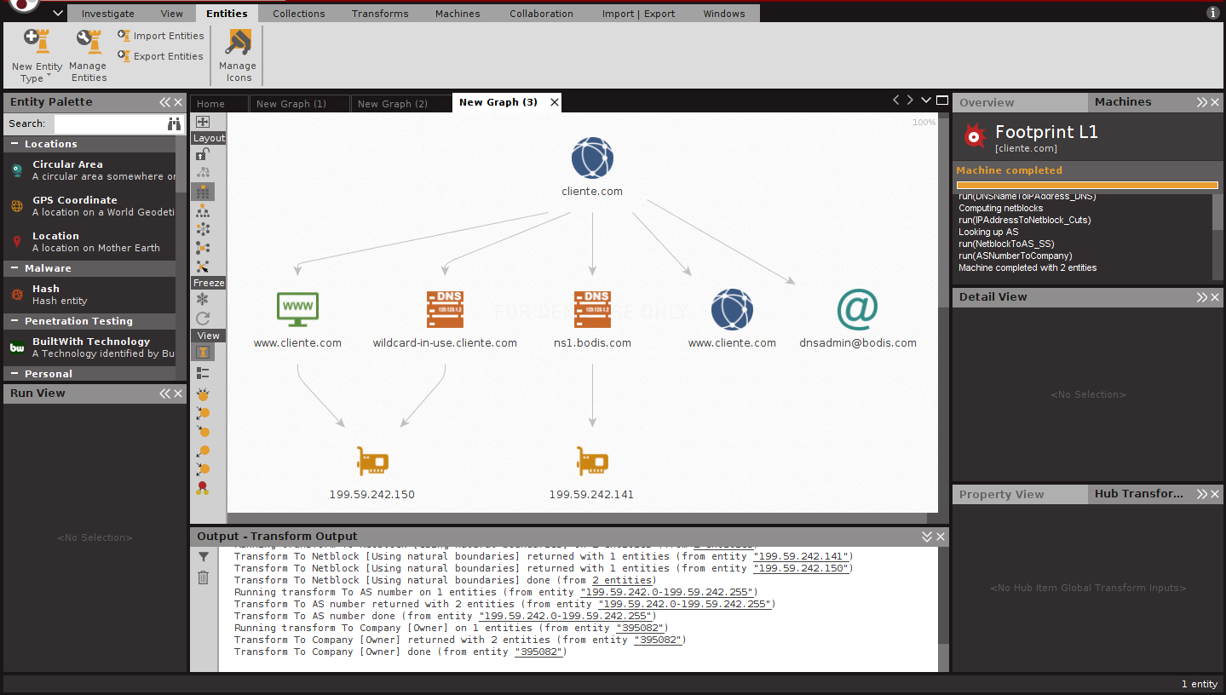

**Metagoofil**

Metagoofil is a Linux-based information gathering tool designed to extract metadata from public documents (.pdf, .doc, .xls, .ppt , .odp, .ods) available on client websites.

Metagoofil generates an html results page with the extracted metadata results, plus a list of possible usernames that might be useful for brute force attacks.

It also extracts the paths and MAC address information from metadata. Metagoofil has some options available, but most are related to what you specifically want to target, as well as the number of desired outcomes.

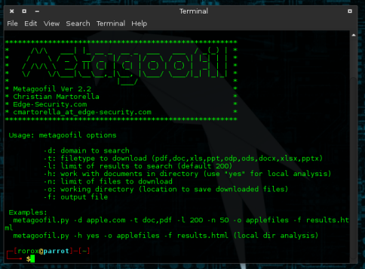

The command to run metagoofil is as follows:

Metagoofil.py -d <customer domain> -l 100 -f everything -o <customer domain>.html -t micro-files

**hping3**

It is a free packet generator and analyzer for the TCP/IP protocol. Hping is one of the tools for security auditing and testing firewalls and networks, and was used to exploit the Idle Scan technique now implemented in the Nmap port scanner. The new hping version, hping3, is scriptable using the Tcl language and implements an engine for string-readable TCP/IP packet description so that the programmer can write scripts related to manipulation and analysis of low-level TCP/IP packets in a very short time.

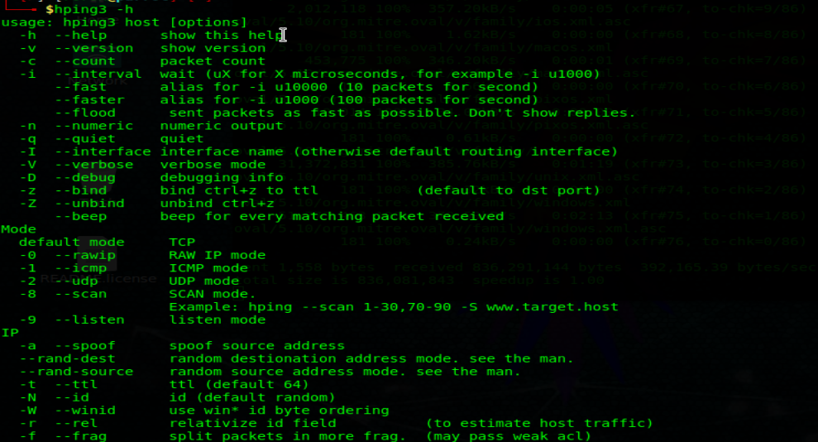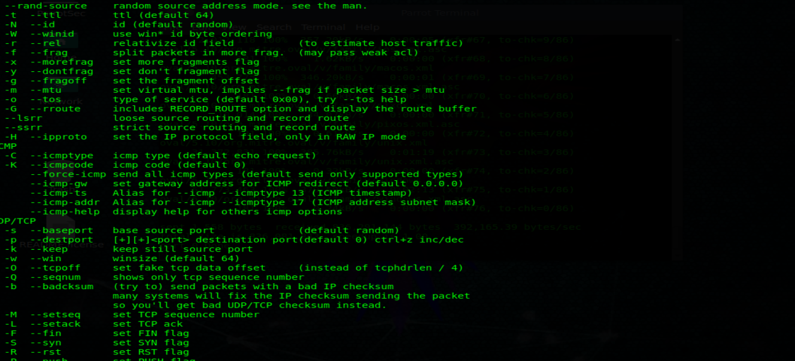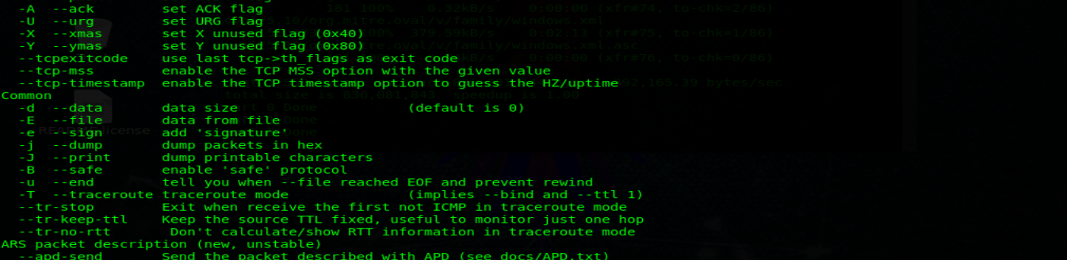

**Method of use:**

hping <Client_domain> <option>

**Ncat**

It is a full-featured network utility that reads and writes data across networks from the command line. Ncat was written for the Nmap Project as a much improved Reimplementation of venerable Netcat. It uses TCP and UDP for communication and is designed to be a reliable back-end tool to instantly provide network connectivity to other applications and users. Ncat will not only work with IPv4 and IPv6 but will provide the user with a virtually unlimited number of potential uses.

Among Ncat's many features are the ability to chain Ncats together, redirect TCP and UDP ports to other sites, SSL support and proxy connections via SOCKS4 proxy or HTTP (CONNECT method) (with optional proxy authentication as well). Some general principles apply to most applications and therefore give you the ability to instantly add network support to software that you would never normally support.

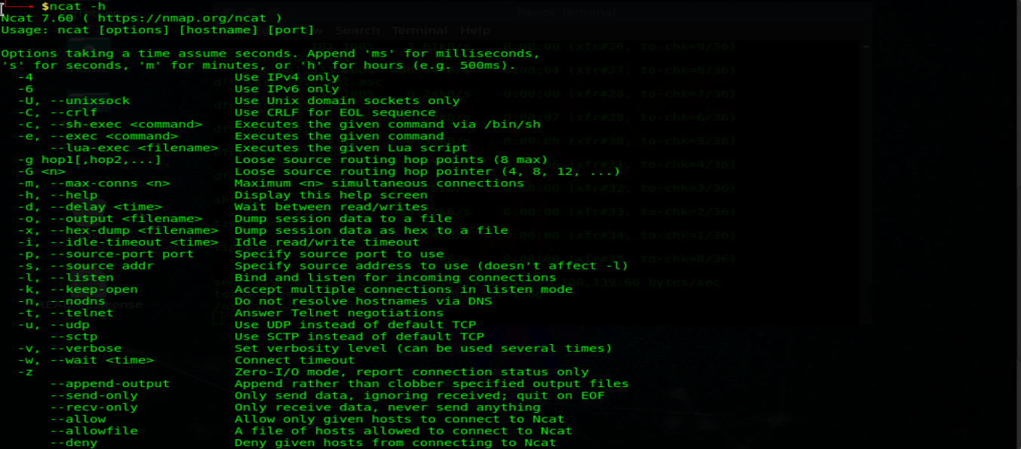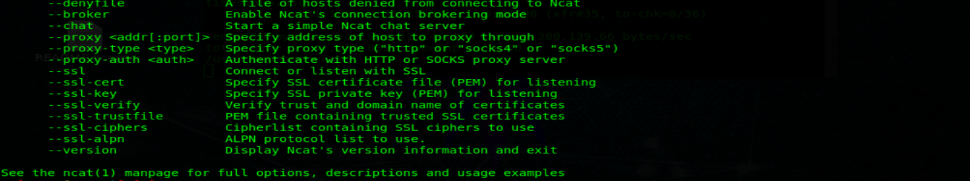

**Method of use:**

ncat <option> <Client_domain> <Port>

**Dmitry**

(Deepmagic Information Gathering Tool) is a UNIX/(GNU) Linux Command Line program coded purely in C with the ability to collect as much information as possible about a host.

DMitry has basic functionality with the ability to add new features. DMitry's basic functionality allows you to collect information about a destination host from a simple whois search on the target to UpTime reports and TCP ports.

The application is considered a tool to assist in the collection of information when it is required quickly, eliminating the need to enter multiple commands and the timely process of searching through data from multiple sources.

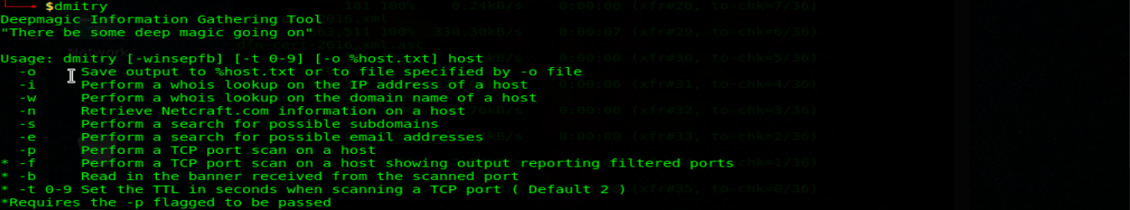

**Method of use:**

dmitry <option> <Client_domain>

**Recon-ng**

Recon-ng is an open source framework coded in python by Tim Tomes, aka LaNMaSteR53. Its interface is modelled after the appearance of the Metasploit Framework, but is not for exploitation or to generate a meter measuring session or a shell, it is for recognition and collection of web-based information. It comes with modules to support your web recognition adventure and information gathering as well as Metasploit's auxiliary and operating modules. The pre-loaded modules for this frame are classified into auxiliary module types, contacts, hosts, output and Pwnedlist.

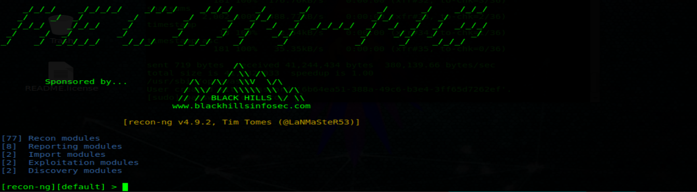

**Method of use:**

1) To see the available modules, we type <Show Modules>  
 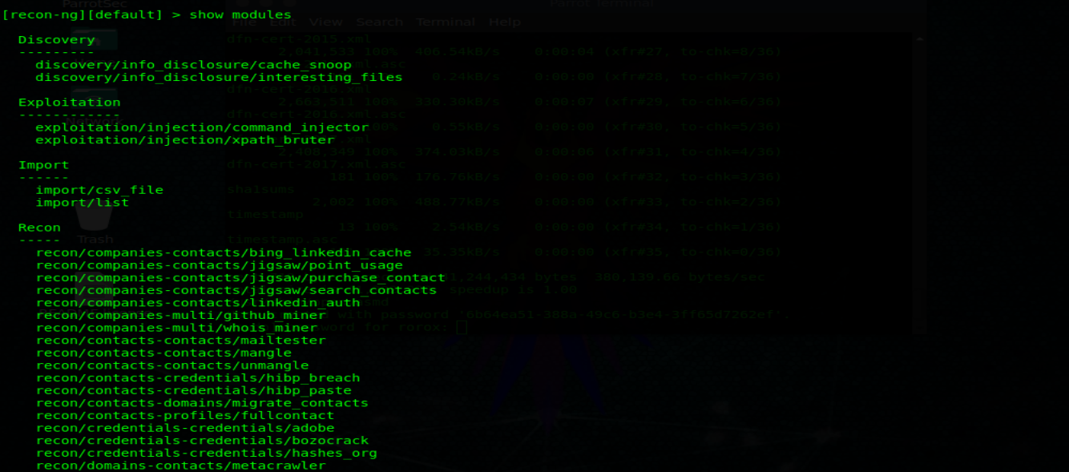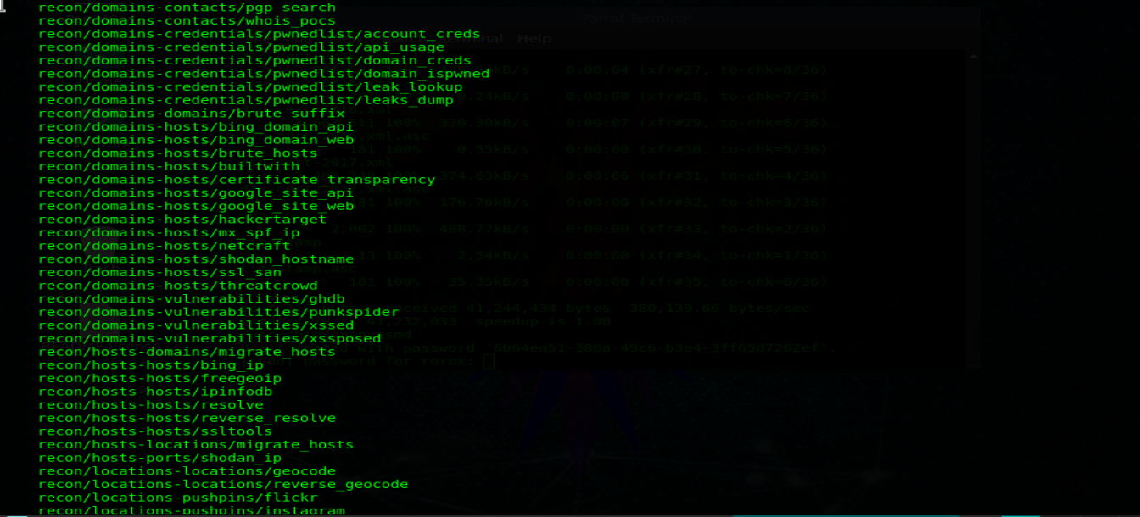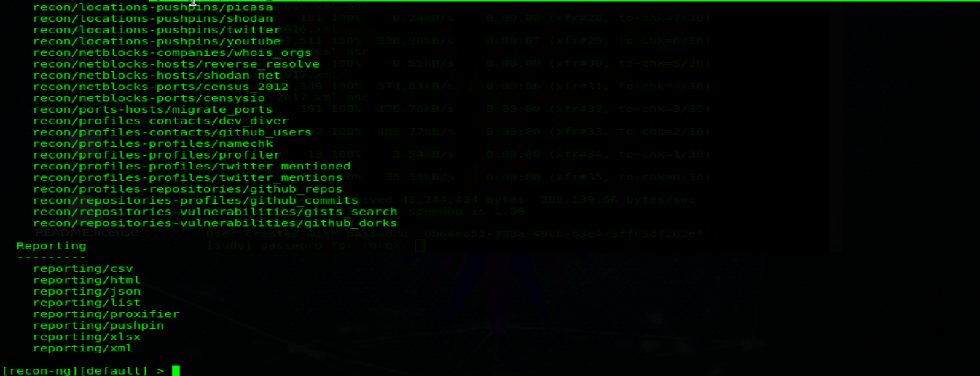

2) We choose the module to use.



3) Fill in the missing data by typing <Show options>



4) We type the missing information with the <Set Source commands "data" > "



5) Execute the module with the command <run>

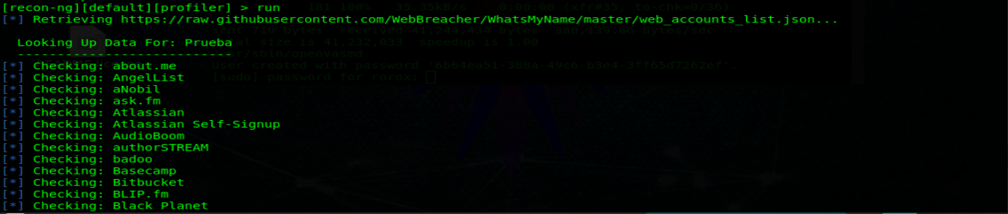

**SET Toolkit**

It's a fantastic piece of software, The Social-Engineer Toolkit or simply SET for short. SET is designed, developed and used by several social engineers. Then let's get started!

The Social-Engineer Toolkit (SET) is specifically designed to perform advanced attacks against the human element. SET was designed to be launched with the launch of https://www.social-engineer.org and quickly became a standard tool in an arsenal of penetration testers. SET was written by David Kennedy (ReL1K) and with a lot of help from the community has incorporated attacks never before seen in a set of exploitation tools. Attacks built into the toolkit are designed for targeted and focused attacks against a person or organization used during a penetration test.

**Familiarizing**

We will start SET with the command:



When you start SET you will see this screen:

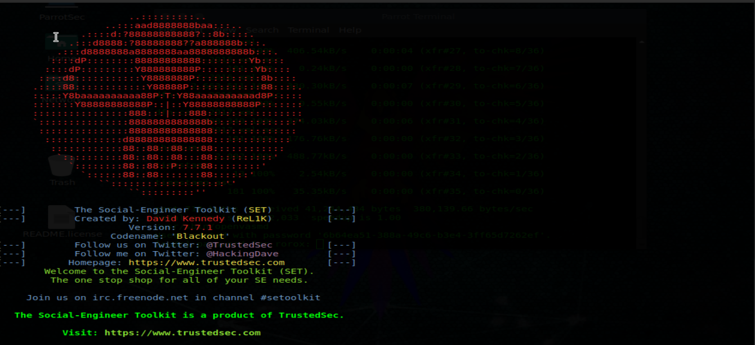

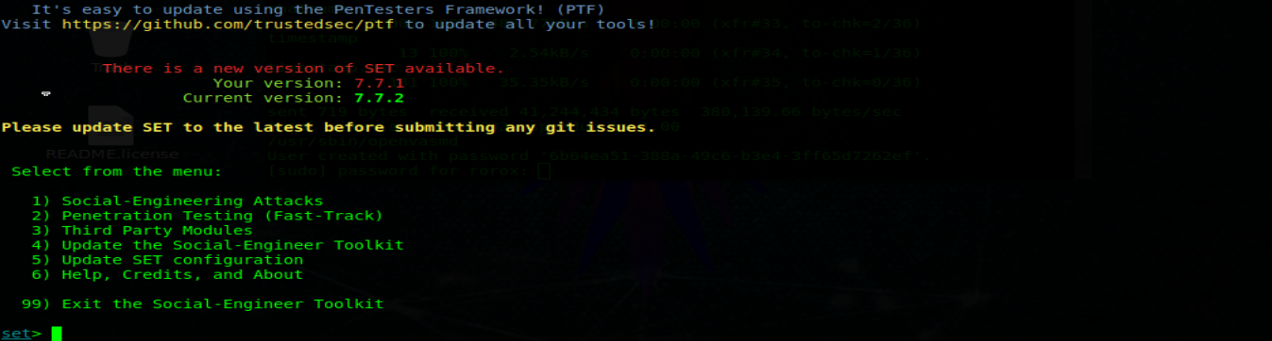

We can now choose one of the options listed above.

We'll use:

**1) Attacks of social engineering**

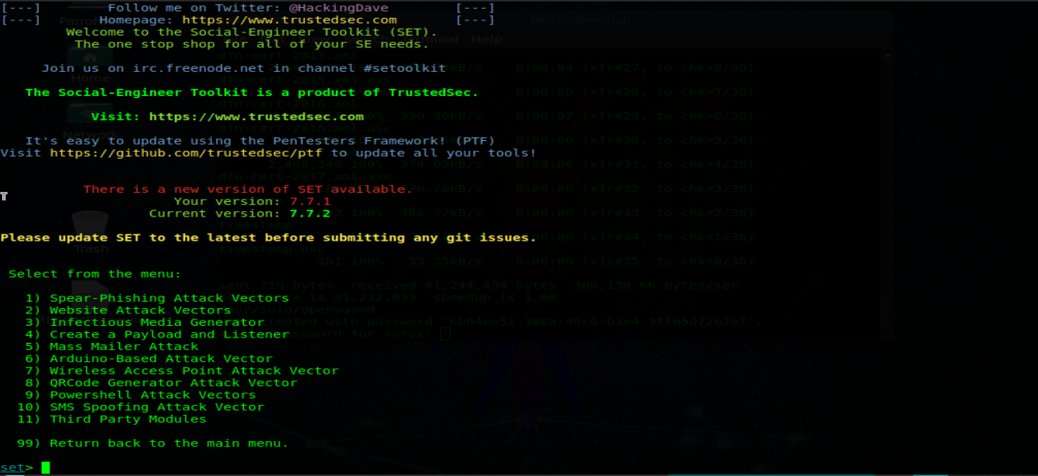

There's a lot of stuff here now, so let's take a look at that!

**Spear-Phishing Attack Vectors**This tool allows you to send emails with a malicious file as a useful upload.

**Website Attack Vectors**This tool allows you to create a malicious website link.

**Generator of infectious media**This tool creates a useful load and .ini file for an injection of USB, CD or DVD.

**Create a payload and listener**Simply create an. exe file and open a listener.

**Mass Mailer Attack**This tool will send emails to the target

**Arduino based attack vector**For use with a “teenage usb”.

**SMS Spoofing Attack Vector**With this tool you can create SMS messages and send them.

**Wireless Access Point Attack Vector**It must be simple.

**QRCode Generator Attack Vector**Generates a QRCode to a specific URL.

**Powershell Attack Vectors**This will allow you to use the Powershell powers (powershell is available in Windows Vista and above).

**Third-party modules**They will allow you to search for more add-ons.

**IKE Scan**

ike-scan discovers fingerprints from IPsecIKE hots (VPN servers)

**ike-scan does two things:**

1. Discovery: Determine which hosts run IKE. This is done by displaying hosts responding to IKE requests sent by ike-scan.
2. Footprints: Determine which IKE implementation you are using. There are several ways to do this:
   1. Backoff fingerprints - record the times of IKE response packets from the target host and compare the observed pattern of backoff retransmission against known patterns.
   2. Fingerprint Provider Identification - matching vendor-specific vendor IDs against known Vendor ID patterns.
   3. Property notification message codes.

The retransmission delay and fingerprint concept is discussed in more detail in the UDP backoff fingerprint document to be included in the ike-scan kit as udp-backoff-fingerprint-paper.txt.

The program sends IKE Phase 1, requests from specified hosts and displays the responses received. Manage and retry backoff relaying to deal with packet loss. It also limits the amount of bandwidth used by outgoing IKE packets.

IKE is Exchange's Internet protocol key, which is the key exchange and authentication mechanism used by IPsec. Almost all modern IPsec VPN systems implement it, and the vast majority of IKE IPsec VPNs use it for key exchange.

Phase-1 has two modes: main mode and aggressive mode. ike-scan supports both main and aggressive mode, and uses the default main mode. RFC 2409 (IKE) section 5 specifies that the main mode must be implemented, therefore all IKE implementations can be expected to support the main mode.

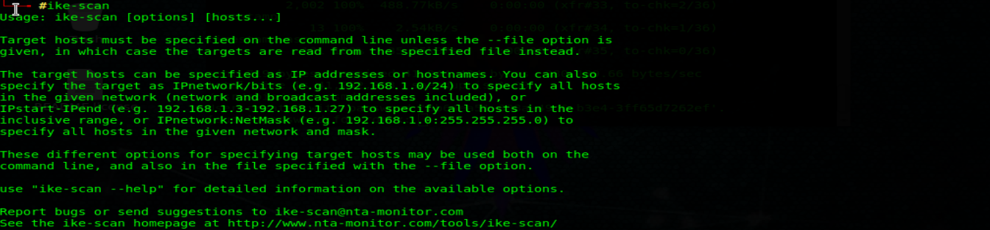

**Syntax**

ike-scan [options] [hots]

**Options**

- Help or -h Displays usage message and ends.

- File = <Fn> o-f <Fn> Reads hostnames or addresses from the specified file rather than from the command line. One name or IP address per line. Use "-" for the standard input.

- Sport = <p> o s-<p> Set the UDP source port to <p>, default = 500, 0 = random. Some IKE implementations require the client to use the UDP 500 source port and does not want to talk to other ports. Note that superuser privileges are normally required to use non-zero source ports below 1024. Also, only one process in a system can link to a given source port at any one time.

- <p> Dport = o-d <p> Set the destination UDP port to <p>, default = 500. UDP port 500 is the port number assigned for ISAKMP and this is the port used by most, if not all, IKE implementations.

- Retry = <n> o-r <n> Initial host wait time setting for <n> ms, default = 500. This wait time is for the first packet sent to each host. Subsequent waiting times are multiplied by the delivery delay factor set with - backoff.

- Timeout = <n> o-t <n> Initial host wait time setting for <n> ms, default = 500. This wait time is for the first packet sent to each host. Subsequent waiting times are multiplied by the delivery delay factor set with - backoff.

- Interval = <n> o-i <n> Set minimum packet interval to <n> ms, default = 75. This controls the use of outgoing bandwidth by limiting the speed at which packets can be sent. The interval between packets shall not be less than this number. Outgoing packets have a total size of 364 bytes (20 bytes IP hdr + 8 bytes UDP HDR + 336 bytes of data) when the default transformation set is used, or 112 bytes if a custom transformation is specified. Therefore, for the joint transformation default: 50 = 58240bps, 36400bps 80 = and custom transformation: 15 = 59733bps, 30 = 35840bps.

- Backoff = <b> o-b <b> Set backoff factor timeout to <b>, default = 1.50. The waiting time per guest is multiplied by this factor after each downtime. Thus, if the number of retry is 3, the initial per host waiting time is 500 ms and the recoil factor is 1.5, then the first waiting time will be 500 ms, 750 ms the second and the third 1125 ms.

- Verbose or v- Displays detailed progress messages. Use more than once for greater effect: 1 - Shows when each step is completed and when packages with invalid cookies are received. 2 - Show each sent and received packet and when hosts are removed from the list. 3 - Displays the host, supplier ID and backoff lists before the search is started.

- Quiet or q- Do not decode the returned packet. This prints less protocol information for shorter production lines.

- Multiline o-M Divide the decoding load across several lines. With this option, decoding for each load is printed on a separate line from a TAB. This option makes the output easier to read, especially when there are many payloads.

- For life = <S> o-l <S> Set life IKE second <S>, default = 28800. RFC 2407 specifies 28,800 by default, but some applications may require different values. If 0 is specified, not all life will be specified. You can use this option more than once in combination with the trans options to produce multiple Transformation loads with different lives. Each option - trans will use the duration value specified above.

- LifeSize = <S> o-z <S> Set IKE to full size Kilobytes <S>, default = 0. If 0 is specified, no natural size is specified. You can use this option more than once in combination with the trans options to produce multiple Transformation loads with different lifesizes. Each trans - option will use the value specified above life-size.

- Auth = <n> o-m <n> Set the auth. method for <n>, default = 1 (pre-shared key). RFC values defined are from 1 to 5. See RFC 2409 Appendix A. Checkpoint hybrid mode is 64221. GSS (Windows "Kerberos") is 65001. XAUTH uses 65001 to 65010.

- Version or V- Displays the program version and exits.

- Vendor = <v> o e-<v> Set Vendor ID string for <v> hexadecimal value. You can use this option more than once to send multiple payloads of supplier identification.

- Trans = <t> o un <t> Use customized <t> transformation instead of a default set. When enc is the encryption algorithm, len is the length of the variable length encryption key, the hash is the hash algorithm, and the group is the DH group. See RFC 2409 Appendix A for more information than the usage values. For example, - trans = 5,2,1,2 specifies Enc = 3DES-CBC, Hash = SHA1, Auth = shared key, DH Group 2 = y - trans = 7/256,1,1,5 specifies Enc = AES-256, Hash MD5 =, Auth = shared key, DH Group = 5 You can use this option more than once to send an arbitrary number of custom transformations.

- Showbackoff[= <n>] o-o[<n>] Display the backoff fingerprint table. View the backoff table for implementing IKE footprint on remote hosts. The optional argument specifies the dwell time in seconds after receiving the last default packet, = 60. If you use the short form of the (-o) option, the value must immediately follow the option letter without spaces, for example-o25-o not 25.

- Fuzz = <n> o-u <n> Set fuzz pattern match to <n> ms, default = 100. This sets the maximum acceptable difference between observed backoff times and reference times in the pattern delivery delay file. Larger values allow for greater variance, but also increase the risk of false positive identifications. Specifying lint by entering patterns in the pattern file will override the setting of this value.

- Patterns = <f> o-p <f> Use pattern file from IKE <f>, default = /usr/local/share/ike-scan/ike-backoff patterns. Specifies the name of the file containing the IKE backoff patterns. This file is used only when - showbackoff is specified.

- Vidpatterns = <f> o-I <f> Use Provider ID of the provider templates <f> file, default = /usr/local/share/ike-scan/ike-vendor-ID. Specifies the name of the file containing the identity provider patterns. These patterns are used for the Vendor ID fingerprint.

- Aggressive o-A Use the IKE Aggressive Mode (the default setting is the main mode) if you specify - aggressive, then you can also specify - dhgroup, - Identification and - ID_type. If you use custom transformations with the aggressive mode with the - trans-option, note that all transformations must have the same DH group and this must match the group specified with - dhgroup or if the defect - dhgroup is not used.

- <id> Id = o-n Use <id> as the identification value. This option only applies to aggressive mode. <id> can be specified as a string, for example - id = test or as a hexadecimal value with the prefix "0x", for example - id = 0xdeadbeef.

- ID_type = n or in- Use <n> type identification. Default 3 (ID_USER_FQDN). This option only applies to aggressive mode. See RFC 2407 4.6.2 for information on identification types.

- Dhgroup = n or gn- Use Diffie Hellman Group <n>. Default 2. This option is only applicable aggressively where it is used to determine the size of the key exchange payload. Acceptable values are 1,2,5,14,15,16,17,18 (MODP only).

- Gssid = <n> o G-<n> Use GSS ID <n> where <n> is a hexadecimal string. This uses transform attribute type 16384 as specified in draft-ietf-ipsec-isakmp-gss-auth-07.txt, although Windows-2000 has been observed to use 32001 as well. On Windows 200, it will have to use – auth = 65001 to specify Kerberos (GSS) for authentication.

- Random-R or randomize the list of hosts. This option randomizes the order of hosts in the host list, so IKE probes are sent to hosts in a random order. The Knuth shuffle algorithm is used.

- Tcp [= n] o-T [n] Use the TCP transport instead of UDP. This allows you to test a host that runs IKE over TCP. Normally, you will not have this option because the vast majority of IPsec IKE systems only support UDP. The <n> optional value that specifies the type of IKE over TCP. There are currently two possible values: 1 = IKE RAW through TCP used by Checkpoint (default) 2 = IKE encapsulation over TCP used by Cisco. If you use the short form of the (-T) option, the value must immediately follow the option letter without spaces, for example-no-T2 T 2. You can only specify a target host only if you use this option.

- TCPtimeout = n or n-O Set the TCP connection timeout to n seconds (default = 10). This only applies to TCP mode of transport.

- Pskcrack [= f] or P [f] Aggressive key mode pre-shared key mode crack. This option generates the pre-shared key (PSK) key mode Parameters for offline cracking using the "psk-crack", which is supplied with ike-scan. If desired, you can specify a file name,"f", to write the parameters to PSK. If no file name is specified, PSK parameters are written to the standard output. If you use the short form of the (-P) option, the value must immediately follow the option letter without spaces, for example-no-P pfile files. You can only specify a target host only if you use this option. This option only applies to aggressive IKE mode.

- Nodns o-N Do not use DNS to resolve names. If you use this option, all hosts must be specified as IP addresses.

**Method of Use:**

ike-scan <option> <Client_domain>

**External Footprinting**

The External Footprinting phase of the Intelligence Meeting involves collecting the response results of an objective based on direct interaction from an external perspective. The aim is to gather as much information about the objective as possible.

**Identification of IP ranges**

For external footprinting, we first need to determine which of the WHOIS servers contains the information we are looking for. Since we must know the TLD for the destination domain, we simply need to locate the Registrar with whom the destination domain is registered.

WHOIS information is based on a tree hierarchy. ICANN (IANA) is the authoritative registry for all TLDs and is a great starting point for all manual WHOIS queries.

**WHOIS Search**

▪ <http://www.icann.org>

▪ <http://www.iana.com>

▪ <http://www.nro.net>

▪ <http://www.afrinic.net>

▪ <http://www.apnic.net>

▪ <http://ws.arin.net>

▪ <http://www.lacnic.net>

▪ <http://www.ripe.net>

Once the appropriate Registrar has been consulted, we may obtain information from the Registrant. There are numerous sites that offer WHOIS information; however, for accuracy in documentation, you need to use only the appropriate registrar.

▪ <http://www.internic.net/> <http://www.internic.net>

**BGP**

It is possible to identify the Autonomous System Number (ASN) for networks participating in the Border Entry Protocol (BGP). From BGP route routes are advertised from all over the world we can find these using a BGP4 and mirror BGP6.

▪ <http://www.Bgp4.as/looking-glasses> </ u>

▪ <http://lg.he.net/>

**Google Dorks:**

▪ <http://www.exploit-db.com/google-dorks>

**Active Footprinting**

The active footprints phase of the Intelligence Gathering involves gathering the response results of an objective based on direct interaction.

**Zone Transfers:**

DNS zone transfer, also known as AXFR, is a type of DNS transaction. It is a mechanism designed to replicate databases containing DNS data through a set of DNS servers. Zone transfer comes in two flavors, full (AXFR) and incremental (IXFR). Numerous tools are available to test the ability to perform a DNS zone transfer. The tools commonly used to perform zone transfers are host, dig and nmap.

**HOST**

Host <Domain> <DNS_Server>

**DIG**

Dig @Server Domain axfr

**Reverse DNS:**

Reverse DNS can be used to obtain valid server name in use within an organization.

There is a warning that you must have a PTR (reverse) DNS record to resolve a name from a provided IP address. If resolved, the results are returned. This is usually done by testing the server with multiple IP addresses to see if it returns any results.

**Fierce2:**

For DNS enumeration, there are two tools that are used to provide the desired results. The first one we'll focus on is called Fierce2. As you can probably guess, this is a modification in Fierce. Fierce2 has many options, but we want to focus on the attempts to make a zone transfer. If that is not possible, then perform DNS queries using multiple server names in an effort to list the registered hostnames.

The command to execute is:

fierce -dns <client_domain> -prefix <word_list>

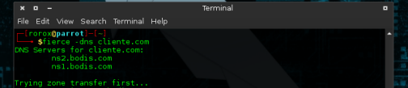

**DNSEnum:**

An alternative to the Fierce2 enumeration for DNS is DNSEnum. As you can probably guess, this is very similar to Fierce2. DNSEnum offers the ability to enumerate DNS through gross force subdomains, perform reverse searches, enumerate domain network ranges and perform whois queries. It also scrapes Google for the names additional to the query.

The command to run dnsenum is as follows:

dnsenum -enum -f <word_list> <client_domain>

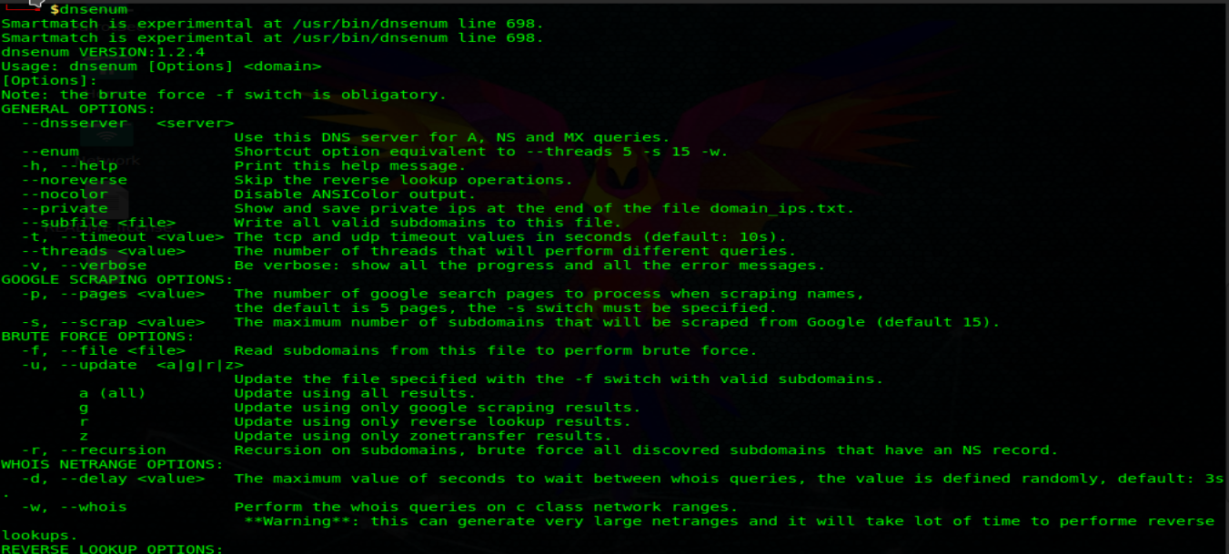



**Method of Use:**

dnsenum -enum <Word_list> <Client_domain>

**Dnsmap:**

Passive network mapper and usually known as brute forcer subdomain. Used during the information gathering/enumeration phase of infrastructure safety assessments. The tool allows you to discover all the subdomains associated with a given domain.

We can find remote access servers, badly configured servers, new domain names that allow you to assign a non-obvious network block.

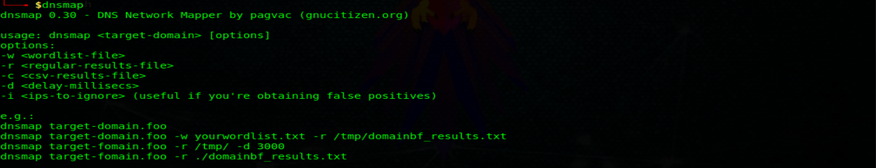

**Method of Use:**

dnsmap <Client_domain>

**DNSrecon**

It allow us:

* Top-level domain extension (zone of displacement and zone transfer)
* Reverse search according to IP range
* Perform a general DNS query for the NS, SOA and MX records (Standard Record Listing)
* Caching of name servers
* Google subdomain and host scanning.

One of the previous things in detail and how to use the DNSRECON tool to do the same:

First of all, we all need to understand what top-level domains are. A Top Level Domain (TLD) is one of the highest level domains in the hierarchical Internet domain name system. For example: At www.mywebsite.com, .com is a top-level domain. As its name suggests, Top Level Domain Expansion means expanding your domain from one region to another that is also known as Zone Transfer and if the zones are not configured correctly, we can extract almost all the internal registrations of a domain that is also known as Zone Walking. So we can use DNS Recon for multiple purposes, that is, Zone Walking and Zone Transfer. It allows you to understand both in detail, that is, how we will use DNSRECON to exploit both features:

**\* Zone Transfer**: The security problem with DNS zone transfer is that it can be used to decrypt a company's network topology. Specifically, when a user is attempting to perform a zone transfer, it sends a DNS query to list all of the DNS information such as name servers, hostnames, xx and CNAME records, zone serial number, Livetime records etc. Due to the amount of information that can be obtained, DNS zone transfer cannot be easily found today. However, DNSRecon provides the ability to perform zone transfers and we can use the following commands to perform zone transfers:

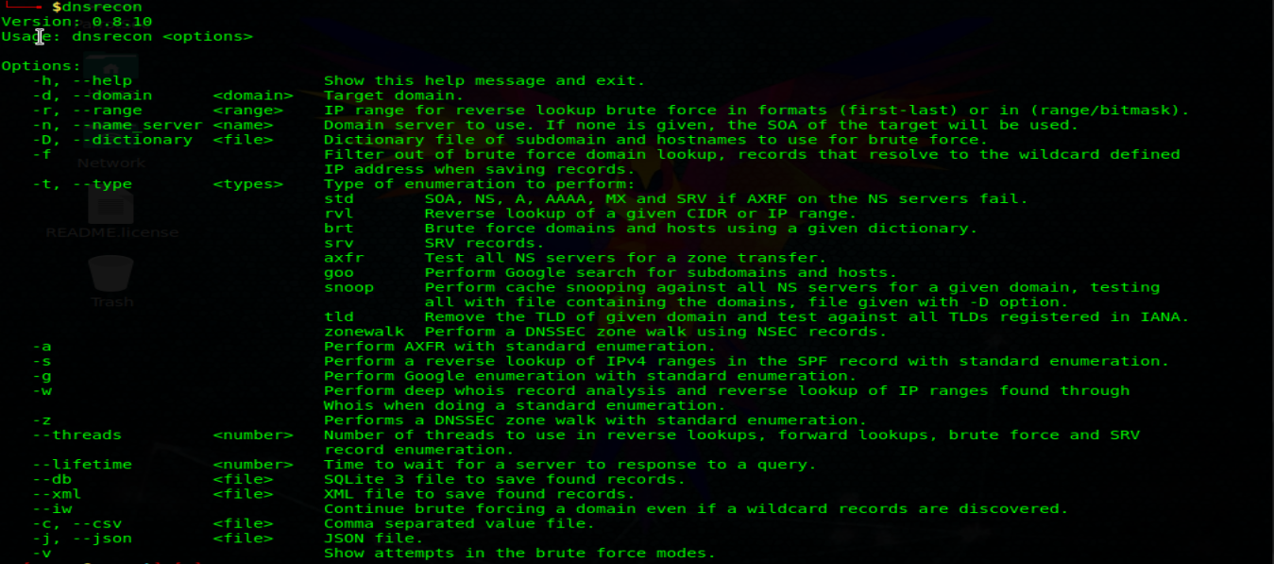

**Method of Use:**

dnsrecon <option> <Client_domain>

**Httprint**

Httprint is a web server fingerprint tool. It relies on web server features to accurately identify web servers, even though they may have been obscured by changing server banner strings, or by plug-ins such as mod_security or servermask. Httprint can also be used to detect web-enabled devices that do not have a server banner string, such as wireless access points, routers, switches, cable modems, etc. Httprint uses text signature strings and it is very easy to add signatures to the signature database.

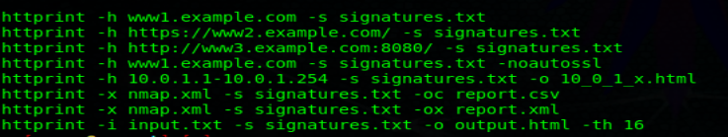

**Method of Use:**

httprint -h <client_domain> -s <file_name> <.extension>

**VoIP Mapping**

VoIP mapping is where we collect information about topology, servers and clients. The main objective is to find live hosts, PBX type and version, VoIP servers/gateways, client types and versions (hardware and software). Most of the techniques covered here assume a basic understanding of the Session Initiation Protocol (SIP). There are several tools available to help us identify and list VoIP-enabled devices.

**Svwar**

Svwar is also a tool in the sipvicious suite that allows you to list extensions using a range of extensions or using a svwar dictionary file. Supports all of the three extension enumeration methods as mentioned above, the default method for enumeration is REGISTER. The use of Svwar is as follows:



**Method of Use:**

svwar <Client_domain>

**ENUMIAX**

If you have identified an Asterisk server in use, you must use a user name divination tool, such as enumIAX, to list the user names of the Asterisk exchange protocol. EnumIAX is a brute-force user name enumeration of the Inter Asterisk Exchange protocol version 2 (IAX2) user name. EnumIAX can operate in two different modes; Sequential username guessing or dictionary attack.

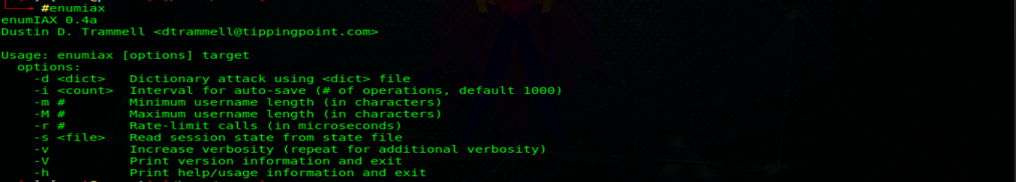

**Method of Use:**

enumiax <option> <client>

**Phase 2: Scanning**

**Port Scanning**

**What are Ports?**

There are many layers in the OSI network model. The transport layer is the layer that deals primarily with communication between different services and applications.

This layer is the main layer to which ports are associated.

**Port Terminology**

Terminology knowledge is required to understand the port configuration. Here are some terms to help you understand the discussion that will follow:

* **Port**: An addressable network location implemented within the operating system that helps distinguish traffic for different applications or services.
* **Internet Sockets**: a file descriptor that specifies an IP address and an associated port number, as well as the transfer protocol that will be used to handle the data.
* **Binding**: The process that occurs when an application or service uses an Internet socket to handle the data it is entering and producing.
* **Listen**: A service is said to be "listening" on a port when it is linked to a combination of port/protocol/IP address to wait for requests from service clients.

Upon receiving a request, establish a connection with the client (when appropriate) using the same port you have been listening to. Because the Internet sockets used are associated with a specific client IP address, this does not prevent the server from listening to and serving requests from other clients simultaneously.

* **Port Scanning**: It is the process of attempting to connect to a series of sequential ports, for the purpose of obtaining information about which ones are open and what services and operating system are behind them.

**Common Ports:**

Ports are specified with a number from 1 to 65535.

* Many ports below 1024 are associated with services that Linux and Unix-like operating systems consider critical for essential network functions, so you must have root privileges to assign services to them.
* Ports between 1024 and 49151 are considered "registered". This means that they can be "reserved" (in a very weak sense of the word) for certain services by issuing an application to the IANA (Internet Assigned Numbers Authority). They are not strictly applied, but they can give a hint about the possible services that are executed in a given port.
* Ports between 49152 and 65535 cannot be registered and are suggested for private use.

Due to the large number of ports available, you will never have to worry about most services that tend to link to specific ports.

However, there are some ports that are whort knowing because of their ubiquity. The following is only a very incomplete list:

* **20**: FTP Data
* **21**: FTP Control Port
* **22**: SSH
* **23**: Telnet <= Unsafe, not recommended for most applications
* **25**: SMTP
* **43**: WHOIS Protocol
* **53**: DNS Services
* **67**: DHCP server port
* **68**: DHCP client port
* **80**: HTTP traffic <= normal web traffic
* **110**: POP3 Mail Port
* **113**: Identity authentication services in IRC networks
* **143**: IMAP Mail Port
* **161**: SNMP
* **194**: IRC
* **389**: LDAP Port
* **443**: HTTPS <= Secure web traffic
* **587**: SMTP <= message sending port
* **631**: CUPS print daemon port
* **666**: DOOM <= This inherited FPS game actually has its own special port

These are just some of the services commonly associated with ports. You must find the appropiate ports for the applications you are trying to configure in their respective documentation.

Most services can be configured to use ports other than the default port, but you must ensure that both the client and the server are configured to use a non-standard port.

You can get a brief list of some common ports by typing:

less /etc/services

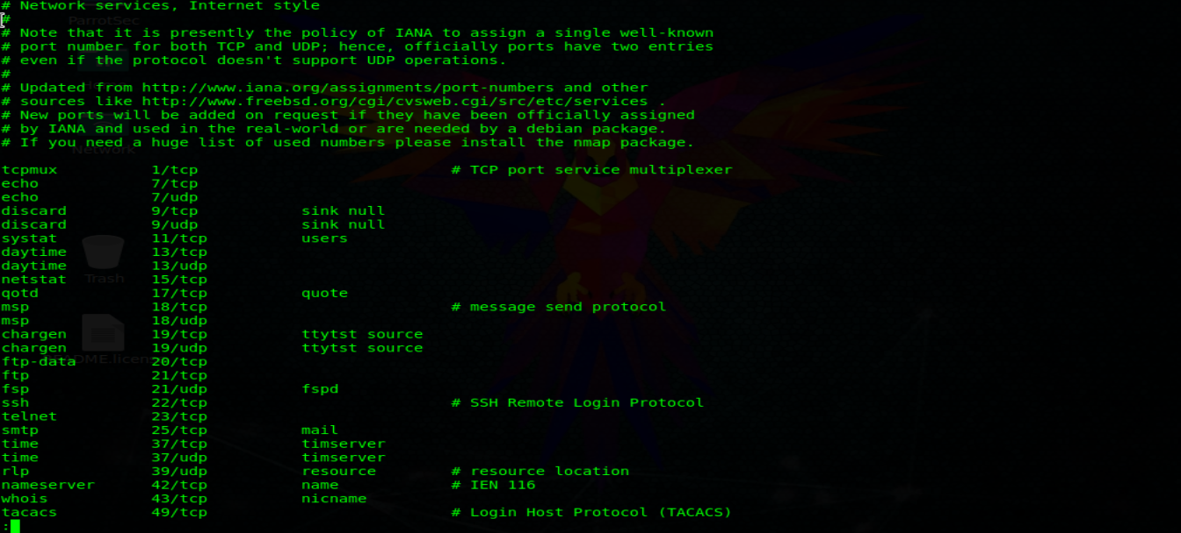

**Nmap**

Nmap (Network Mapper) is the standard for network auditing/scanning. Nmap runs on Linux and Windows. Nmap is available in command line and GUI versions. For the sake of this document, we will just conver the command line.

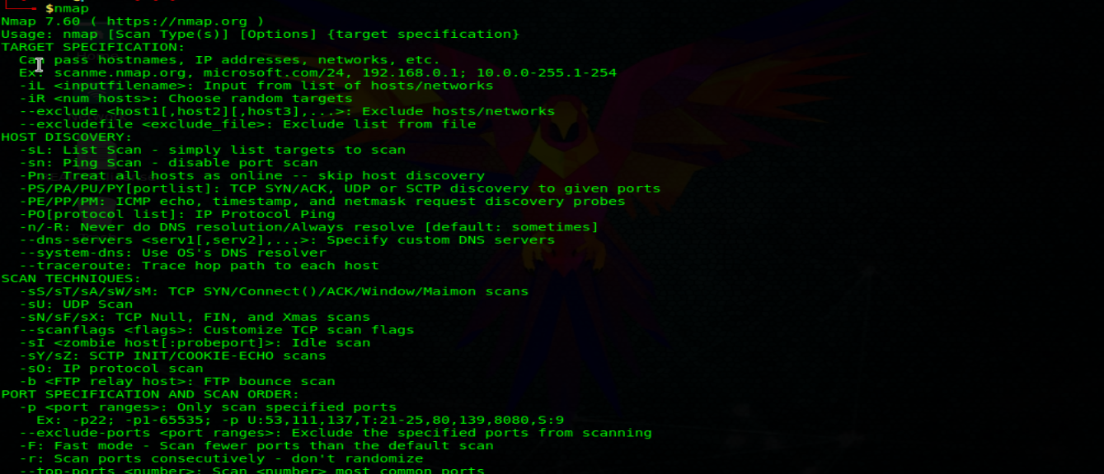

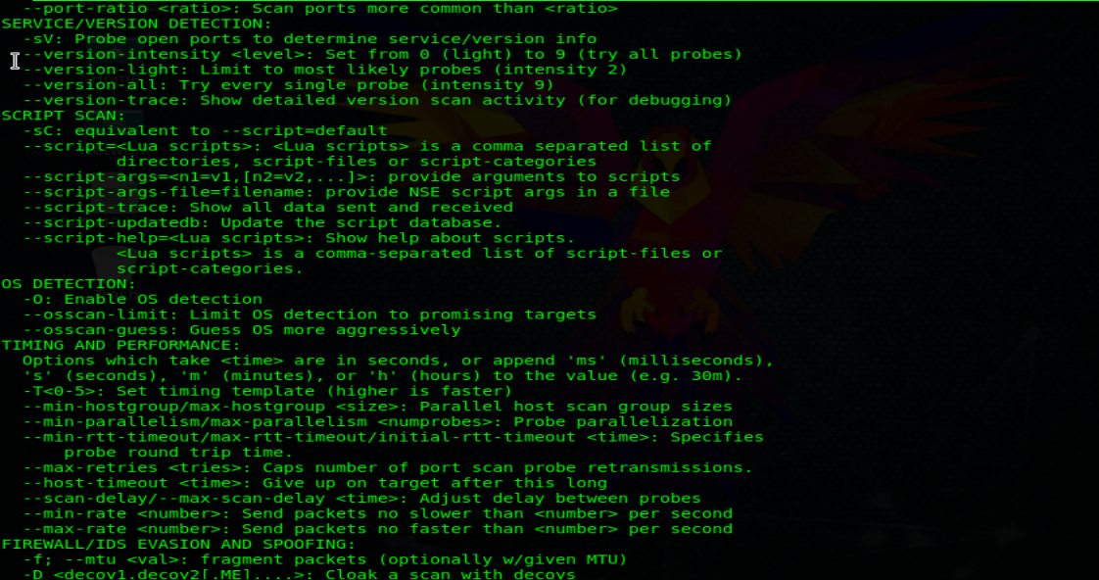

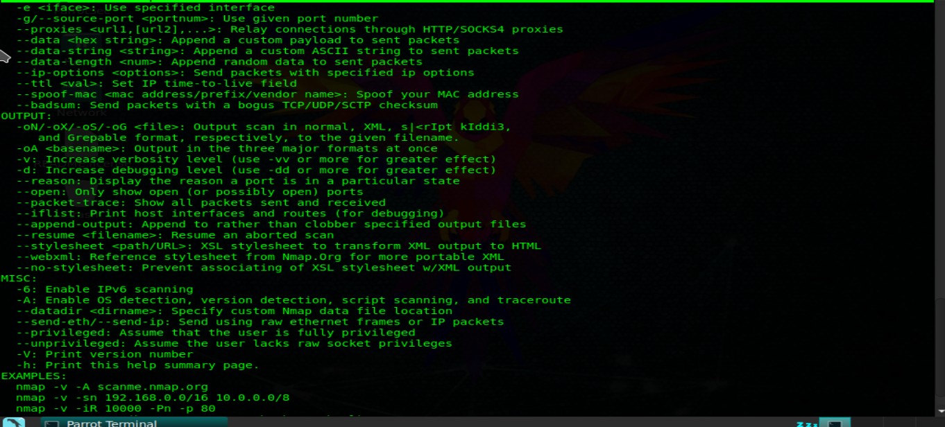

These are some common operations that can be performed with nmap. We will run them all with sudo privileges to avoid returning partial results for some queries. Some commands may take a long time to complete:

Find the host operating system:

nmap -o <client_domain>

Skip the network discovery part and assume the host is online. This is useful if you get an answer that says "Note: Host seems to be" in your other tests. Add to this other option:

nmap -Pn <Client_domain>

Specify a range with “-” or “/24” to scan one number of hosts at a time:

nmap -Pn <Client_domain> /24

Scan a network range for available services:

nmap -sP <Client_domain> /24

Scans without preforming a reverse DNS search in the specified IP address. This should speed up your results in most cases:

nmap -n <Client_domain>

Scan a specific port instead of all common ports:

nmap -p <Client_domain>

To search for TCP connections, nmap can perform a 3-way handshake (explained below) with the destination port. Run it this way:

nmap -St <Client_domain>

To search UDP connections, write:

nmap -sU <Client_domain>

Analize each open TCP and UDP port:

nmap -n -Pn -St -sU -p <Client_domain>

**Connections and services scanning:**

A TCP scan “SYN” scans the way TCP establishes a connection:

To start a TCP connection, the requesting end sends a "sync request" packet to the server. The server then sends an "acknowledgement of receipt synchronization"packet. The original sender then returns an "acknowledgement of receipt" packet to the server, and a connection is established.

A "SYN" scan, however, discards the connection when the first packet is returned from the server. This is called "semi-open" scanning and used to be promoted as a way of surreptitiously scanning ports, as the application associated with that port would not receive traffic because the connection is never completed.

This is no longer considered stealthy with the adoption of more advanced firewalls and incomplete SYN request marking in many configurations.

To perform a SYN scan, run:

nmap -sS <Client_domain>

A more sneaky approach is sending invalid TCP headers, which, if the host conforms to TCO specificactions, must send a packet back if that port is colsed. This will work on non-Windows based servers.

You can use the indicators: “-sF”, “-sX” or “-sN”. All of them will produce the answer we seek:

nmap -Pn -p <Port> -sN <Client_domain>

To see which version of a service is running on the host, you can try this command. It tries to determine the service and version by testing different server responses:

nmap -Pn -p <Port> -sV <Client_domain>

Nmap has dozens of options available. Since this section is about port scanning, we will focus on the commands needed to do this. It is important to note that the commands used depend mainly on the time and number of hosts being scanned. The more hosts or less time you have to perform these tasks, the less you will interrogate the host. This will become apparent as we continue to discuss the options.

Based on the IP set being evaluated, you will want to scan TCP and UDP ports across the range from 1 to 65535. The command to be used is the following:

nmap -A -Pn -sU -sS -T2 -v -p 1-65535 <Customer_IP_range>

In large IP arrays, those eith more than 100 IP address do not specify a port range. The commad to be used is the following:

nmap -A -O -Pn <Customer_IP_range>

Note that Nmap has limited options for IPv6. These include TCP connect (sT), ping (-sn), List scan (-sL) and version detection.

nmap -6 -sT -pO fe80 xxxx:xxxx:xxxx:xxxx% 12

**SNMP Sweeps**

SNMP sweeps are also performed, as they provide tons of information about a specific system. The SNMP protocol is a stateless, datagram-oriented protocol. Unfortunately, SNMP servers do not respond to requests eith invaled community strings and the underlying UDP protocol does not reliably report closed UDP ports. This means that “no response” from a probed IP address can mean any of the following:

* Inaccessible machine
* SNMP server is not running
* Invalid community string
* The response datagram has not yet arrived

**Banner Grabbing**

Banner Grabbing is a enumaration technique used to collect information about computer systems on a network and the services that run its open ports. Banner Grabbing is used to identify the network version of the applications and operating system that the target hosts are running.

Banner Grabbing is usually done in Hyper Text Transfer Protocol (HTTP), File Transfer Protocol (FTP), and Simple Mail Transfer Protocol (SMTP); Ports 80, 21 and 25 respectively. Tools commonly used to capture banners are Telnet, nmap and Netcat.

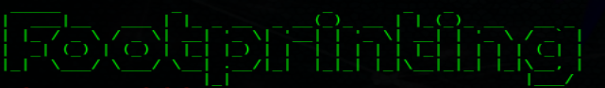

The internal Footprinting phase of intelligence gathering involves the collection of response results from an objective based o direct interaction from an internal perspective. The aim is gather as much informatioin about the objective as possible.

**Active Footprinting**

The active footprints phase if the Intelligence Gathering involves gathering the response results of an objective based on direct interaction.

**Ping Sweeps**

The active print begins with the identification of living systems. This is usually done by performing a ping sweep to determine which hosts respond.

- Nmap has dozens of options available. Since this section is about port scanning, we will focus on the commands needed to do this. It is important to note that the commands used depend mainly on the time and number of hosts being scanned. The more hosts or less time you have to perform these tasks, the less you will interrogate the host. This will become apparent as we continue to discuss the options.

To perform a ping sweep, I would like to use the following command:

nmap -sn <Client_IP_range> /<Mask>

**Vulnerablity Analysis and Scanning**

Vulnerability Analysis is used to identify and assess security risks posed by identified vulnerabilities. Vulnerability analysis work is divided into two areas: Identification and Validation. The vulnerability discovery effort is the key component of the identification phase. Validation is reducing the number of vulnerabilities identified to only those that are actually valid.